Luminex assays are based on xMAP® technology (multi-analyte profiling beads) enabling the detection and quantitation of multiple RNA, DNA or protein targets simultaneously. The Luminex xMAP system combines a flow cytometer, fluorescent-dyed microspheres (beads), lasers and digital signal processing to effectively allow multiplexing of up to 100 unique assays within a single sample.

The QuantiGene Plex DNA Assay is a hybridization-based assay using the xMAP® Luminex® magnetic beads and performed on 96-well plates. The assay is based on DIRECT quantification of the DNA targets using xMAP Luminex beads for multiplexing of 3 to 33 DNA targets and branched DNA (bDNA) signal amplification technology. On the first day the sample is lysed to release the DNAs, and incubated overnight with target specific probe sets panel. On the second day the signal amplification tree is build via sequential hybridization of PreAmplifier (PreAmp), Amplifier (Amp) and Label Probe (LP). Each amplification unit gives a 400 x signal amplification and there are six amplification units per target DNA copy leading to a 2,400 x signal amplification per copy DNA. The signal is detected by adding SAPE substrate and using a Luminex instrument for the read out.

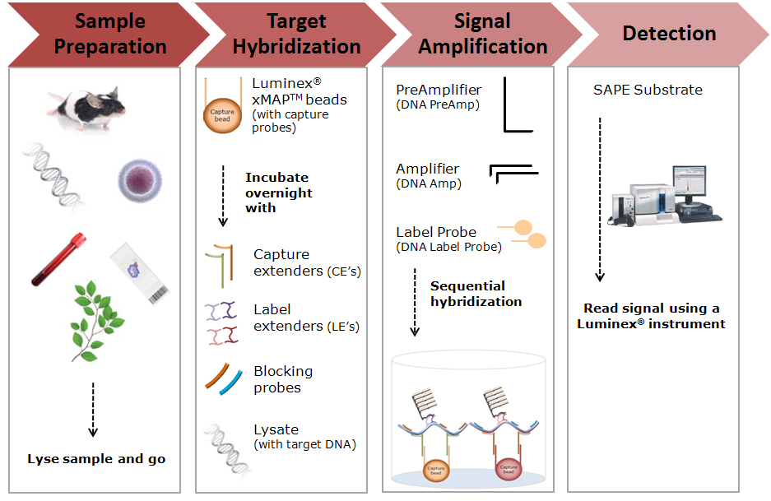

**Step 1-Sample Preparation**: Samples are lysed to release and stabilize DNA’s. The DNA assay works with a variety of samples such as: cultured cells, human, plant and animal tissues, FFPE tissues, whole blood and PAXGene blood, or purified DNA.  
  
**Step 2-Target Hybridization**: Overnight hybridization in the 96-well plates with the target specific probe sets panel (Capture extenders – CE’s, Label Extenders – LE’s and blocking probes).    
  
**Step 3-Signal Amplification**: Signal amplification is achieved using branch DNA (bDNA) technology. A Pre-Amplifier (PreAmp) molecule hybridizes to each pair of Label Extenders, but not to individual probes. Then, multiple Amplifier (Amp) molecules hybridize to each PreAmp. Finally, multiple Label Probe oligonucleotides hybridize to each Amp.  
  
**Step 4-Detection**: Addition of streptavidin phycoerythrin (SAPE) generates a signal that is proportional with the amount of target DNA present in the sample. The signal is read using a Luminex instrument.

<http://www.panomics.com/downloads/LUMINEX_V1.pdf>